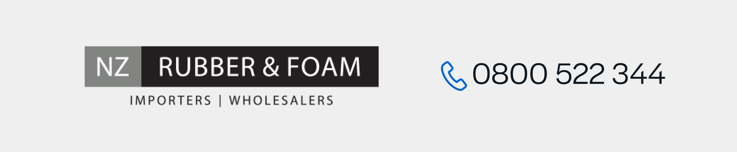
EVA Foam Sheet (81kg/m³)
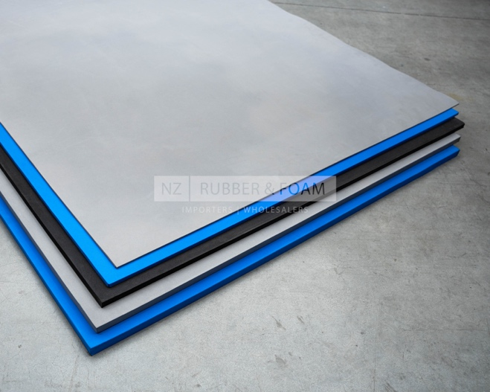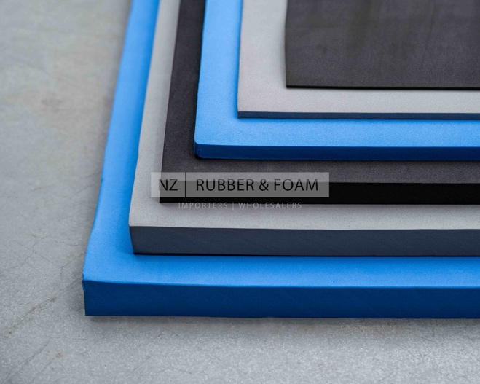

Colours |  | Grey, Blue, Black
Compression Set  (Room temp 22hr) | ASTM D1056 | 70%
Temperature Range |  | -10°C - +70°C (approx.)
Tensile Strength | JIS K6767 | 6.0-9.0 kg/cm2
Elongation | JIS K6767 | 80-120%
Hardness |  | 60 Shore OO
Surface |  | Plain both sides
Density | JIS K6767 | 0.10 +/- 0.02 g/cm³
Tear Strength | JIS K6767 | 2.0-4.0 kg/cm2
Structure | Closed Cell

Chemical Composition:
- Ethylene Vinyl Acetate (EVA) Resin
- Polyethylene Resin
- Calcium Carbonate
- Zinc Oxide
- Azodicarbonamide
- Dicumyl Peroxide
- Steric Acid

